Using a Flow Chart in your Planning for Making

All these symbols are in Word under ‘Insert’ – ‘Shapes’- ‘Flowchart’

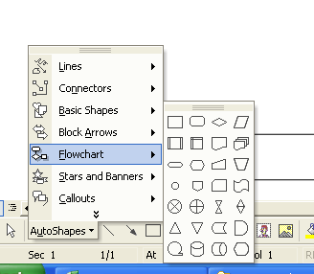

These are used to signify the Start or end of a Flow chart

These boxes contain instruction

These are decision boxes

Start

Measure length
Yes
No
Cut to length
QA – Is it OK?

