The current building was put up in the 1960s to replace the older Edwardian station that had falling into disrepair; although improvements have been made it is still of poor quality and does not meet the needs of the traveller. It does include a shop and a small café as well as the ticket office, toilet facilities are accessed from the west bound platform.

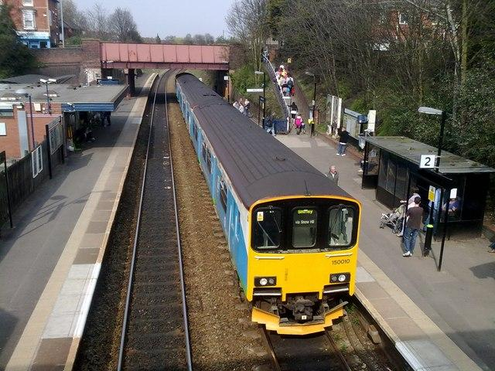

Current Road Bridge

Possible location of Building

Proposed Platforms 1-6

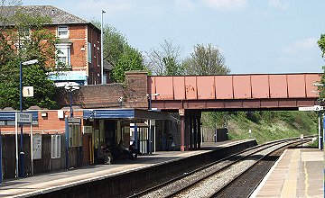

There are only two lines at present, this will be extended to six to improve flow, and the area to the right in the picture below will be cleared to allow the extension. The road bridge at the west end will need to be replaced as well

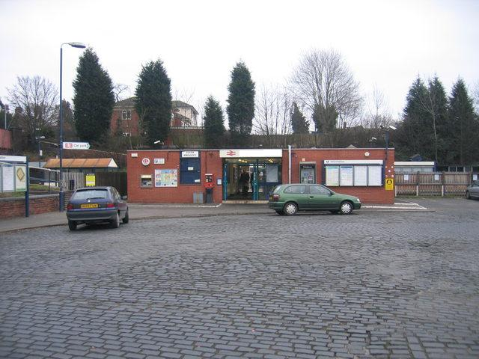

Current Station

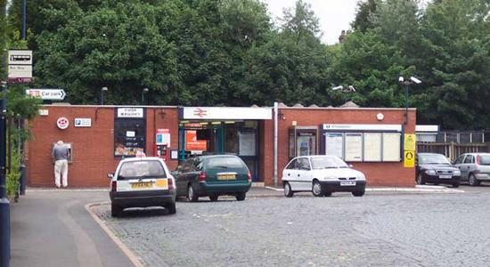

Proposed Track layout, the slow trains take the outside tracks

Harchester West Station – Proposed Layout

Current Footbridge which needs to be replaced or removed

